# **Intro to Deep Learning**

# **Instructions:**

* Answer all questions **clearly and concisely.**
* Support answers with diagrams, equations, or examples where necessary.
* Cite sources (especially book chapters mentioned) where applicable.
* Write in your **own words** — avoid copying from the internet.
* Submit your completed assignment in **Github Repo Link (PDF+Code Notebook)**

## **Section A: Fundamentals of Deep Learning**

### **Q1. What is Deep Learning?**

Explain the concept of deep learning.

* How is it different from traditional machine learning?

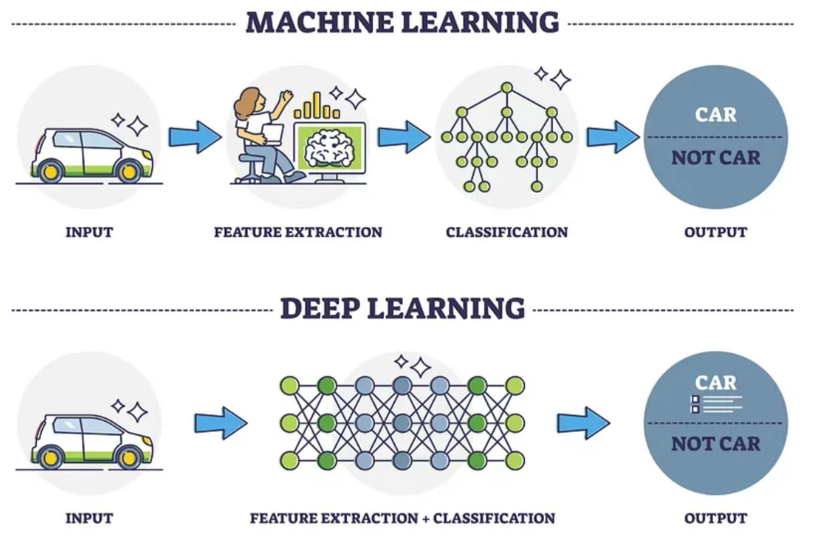

* + The main difference between ML and DL is:
  + 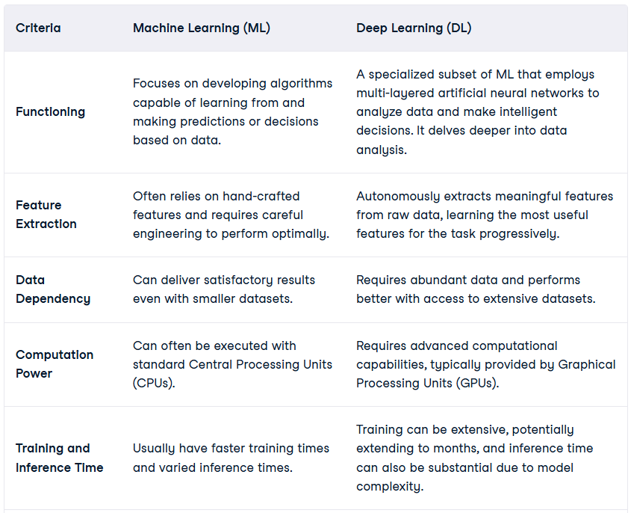
* Why is it called “deep”?  
   ML includes lots of various algorithms starting from Linear Regression to Random Forests. On the other hand, as an overwhelmingly capable part of ML, Deep Learning has specific types of architectures like Deep Neural Networks or Recurrent Neural Networks. Interestingly, these architectures are actually ‘deep’, which means there will be multiple amount of hidden layers in the networks.

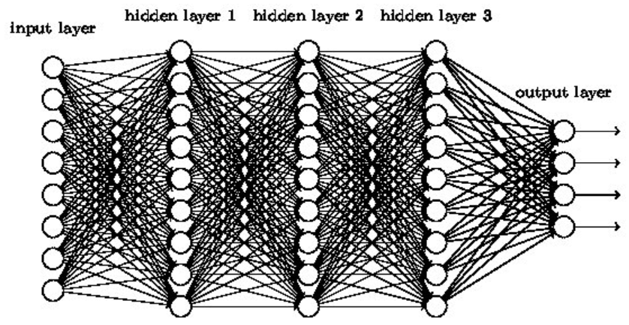

You can think of it this way - to learn something and then to do the recognition, such networks like the one above have to do a lot of computations in multiple layers. They have to go ‘deep’. Hence, Deep Learning. This may look pretty simple - increase hidden layers and then you are doing a deep learning.But of course this is overwhelmingly complex. The amount of computation needed to train a Deep Neural Network is so much high that we require powerful devices, like GPUs.

### **Q2. Key Components of Deep Learning**

List and describe the **main components** of a deep learning model (e.g., neural networks deep neural networks (DNNs), layers, activation functions, loss functions, optimizers).  
 ✎ **Answer:** A neural network is a type of artificial intelligence and machine learning model, inspired by the structure of the human brain, that learns to identify patterns in data to perform tasks like recognizing images, understanding language, and making predictions. It consists of layers of interconnected artificial "neurons" or nodes, which are organized into an **input layer**, one or more **hidden layers**, and an **output layer**. During a process called **training**, the network adjusts the strength of connections between these neurons (known as weights and biases) using training data to improve its accuracy over time.These networks are built from several key components:

* **Neurons**: The basic units that receive inputs, each neuron is governed by a threshold and an activation function.
* **Connections**: Links between neurons that carry information, regulated by weights and biases.
* **Weights and Biases**: These parameters determine the strength and influence of connections.
* **Propagation Functions**: Mechanisms that help process and transfer data across layers of neurons.
* **Learning Rule**: The method that adjusts weights and biases over time to improve accuracy.

Activation functions introduce an additional step at each layer during the forward propagation, but its computation is worth it. Let’s suppose we have a neural network working without the activation functions.

In that case, every neuron will only be performing a linear transformation on the inputs using the weights and biases. It’s because it doesn’t matter how many hidden layers we attach in the neural network; all layers will behave in the same way because the composition of two linear functions is a linear function itself.

Although the neural network becomes simpler, learning any complex task is impossible, and our model would be just a linear regression model.

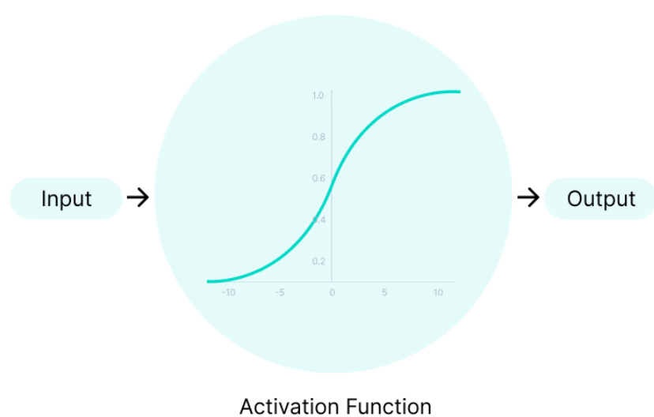

A loss function in neural networks is a mathematical function that compares the predicted output of the network and the true output (label). The difference between these two values represents the error or loss. The goal of training a neural network is to minimize the value of the loss function, by adjusting the weights and biases, thereby achieving a good fit to the training data. This is done by using an optimization algorithm, such as gradient descent. So, the aim of a loss function in a neural network is to provide a measure of how well the network is performing on a given task.

**Loss Function:** The loss function is used to evaluate the performance of the network on a single training example. It provides a way to quantify the difference between the predicted output and the true output for that example.

**Cost Function:** The cost function is used to evaluate the performance of the network over the entire training dataset. It provides an average measure of the error made by the network on the training data. The cost function is calculated by summing the loss values for each training example and dividing by the number of examples. The cost function can also include regularization terms, which are used to prevent overfitting in the network.

### **Q3. Understanding Neural Networks, Neurons, and the Perceptron**

Explain the structure and working of:

* 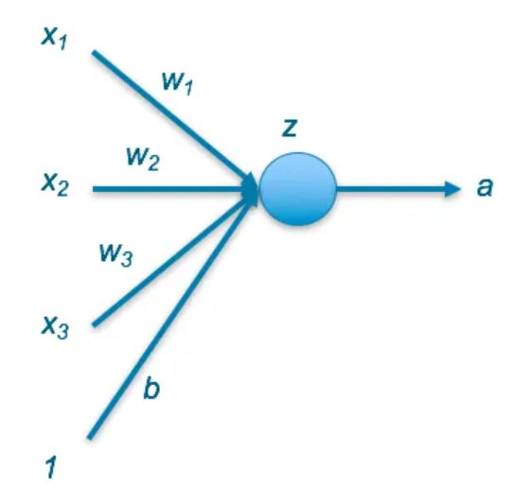The **perceptron model** (include formula and diagram)
  + An artificial neuron (also referred to as a perceptron) is a mathematical function. It takes one or more inputs that are multiplied by values called “weights” and added together. This value is then passed to a non-linear function, known as an ***activation function***, to become the neuron’s output.
  + The x values refer to inputs, either the original features or inputs from a previous hidden layer
  + At each layer, there is also a bias b which can help better fit the data
  + The neuron passes the value a to all neurons it is connected to in the next layer, or returns it as the final value
  + 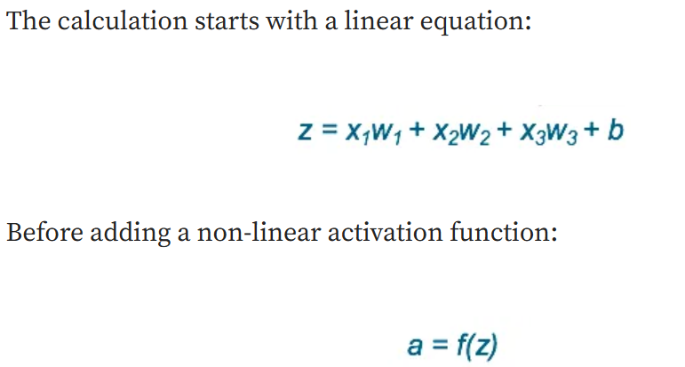  
    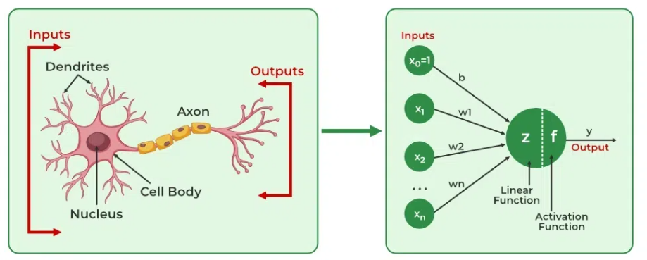
* A **neuron** in a neural network
  + In an artificial neural network, a neuron is a computational unit, analogous to a biological nerve cell, that receives, processes, and transmits data. It performs a mathematical operation on its weighted inputs and applies an activation function to produce an output, which is then passed to other neurons. Neurons are the fundamental building blocks of neural networks, organized into layers to learn complex patterns and solve problems.
* How multiple perceptrons form a **neural network** ✎ **Answer:** When **many neurons (perceptrons)** are connected together in **layers**, they form a **neural network**.
  + **Input layer:** Receives the raw data (e.g., pixel values).
  + **Hidden layers:** Contain multiple neurons that learn patterns and features.
  + **Output layer:** Produces the final result (e.g., class label or prediction).
  + Each neuron in one layer connects to neurons in the next layer through **weighted connections**, allowing the network to learn complex relationships in data.

### **Q4. Hierarchical Representations**

**What are hierarchical representations in deep learning? Explain how features evolve from low-level** (edges, lines) **to high-level** (objects, faces)**.**  
 ✎ **Answer:** Hierarchical representation is the core principle that allows deep neural networks to learn progressively complex features by stacking multiple layers. Each layer acts as a filter that transforms a simple input into a slightly more abstract and meaningful output, which then serves as the input for the next layer.

* **Shallow Layers:** Edges, Corners, Gradients, and Lines. These are general-purpose detectors of basic pixel differences (e.g., a diagonal line or a sharp shift from light to dark).
* **Intermediate Layers:** It captures mid-level features like Textures, Motifs, and Parts**.** The network combines the simple edges to form more meaningful shapes like circles, arcs, checkerboard patterns, or the specific texture of fur or wood.
* **Deep Layers:** These are mostly last layers and used to capture high level features including Object Parts and Semantic Concepts. The network recognizes complex, abstract concepts like an entire **eye**, a **nose**, a **wheel**, or a specific **face**. These features are highly specialized and directly correspond to the object the network is trying to classify.

### **Q5. Fitting Parameters using Backpropagation**

**Describe the backpropagation algorithm.  
 How does it adjust network parameters during training?**  
 ✎ **Answer:** To train a neural network, there are 2 passes (phases):

1. Forward
2. Backward

In the forward pass, we start by propagating the data inputs to the input layer, go through the hidden layer(s), measure the network’s predictions from the output layer, and finally calculate the network error based on the predictions the network made.

This network error measures how far the network is from making the correct prediction. For example, if the correct output is 4 and the network’s prediction is 1.3, then the absolute error of the network is 4-1.3=2.7. Note that the process of propagating the inputs from the input layer to the output layer is called **forward propagation**. Once the network error is calculated, then the forward propagation phase has ended, and backward pass starts.

The next figure shows a red arrow pointing in the direction of the forward propagation.

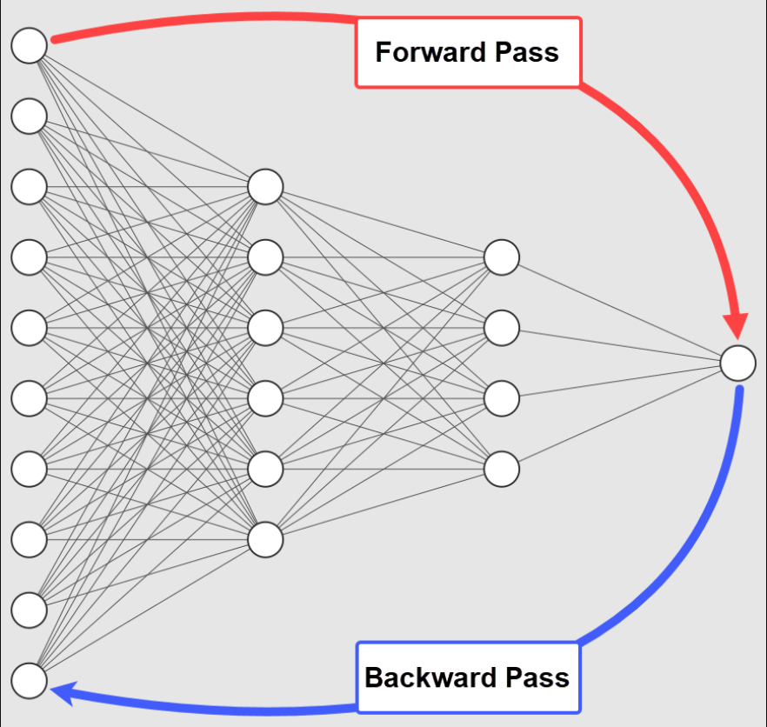

In the backward pass, the flow is reversed so that we start by propagating the error to the output layer until reaching the input layer passing through the hidden layer(s). The process of propagating the network error from the output layer to the input layer is called **backward propagation**, or simple **backpropagation**. The backpropagation algorithm is the set of steps used to update network weights to reduce the network error.

In the next figure, the blue arrow points in the direction of backward propagation.

The forward and backward phases are repeated from some epochs. In each epoch, the following occurs:

1. The inputs are propagated from the input to the output layer.
2. The network error is calculated.
3. The error is propagated from the output layer to the input layer.

If the current error is high, the network didn’t learn properly from the data. What does this mean? It means that the current set of weights isn’t accurate enough to reduce the network error and make accurate predictions. As a result, we should update network weights to reduce the network error.

The backpropagation algorithm is one of the algorithms responsible for updating network weights with the objective of reducing the network error.

Here are some of the advantages of the backpropagation algorithm:

* It’s memory-efficient in calculating the derivatives, as it uses less memory compared to other optimization algorithms, like the genetic algorithm. This is a very important feature, especially with large networks.
* The backpropagation algorithm is fast, especially for small and medium-sized networks. As more layers and neurons are added, it starts to get slower as more derivatives are calculated.
* This algorithm is generic enough to work with different network architectures, like convolutional neural networks, generative adversarial networks, fully-connected networks, and more.
* There are no parameters to tune the backpropagation algorithm, so there’s less overhead. The only parameters in the process are related to the gradient descent algorithm, like learning rate.

### **Q6. Non-Convex Functions**

What are non-convex functions, and why do they make optimization challenging in deep learning?  
 ✎ **Answer:** A non-convex function is a function whose graph has multiple local minima and maxima rather than a single global minimum.  
In other words, the loss surface is irregular and complex, with many “valleys” and “peaks.”

Mathematically, a function f(x) is convex if the line segment between any two points on its curve lies above or on the curve. If this condition is not met, the function is non-convex.

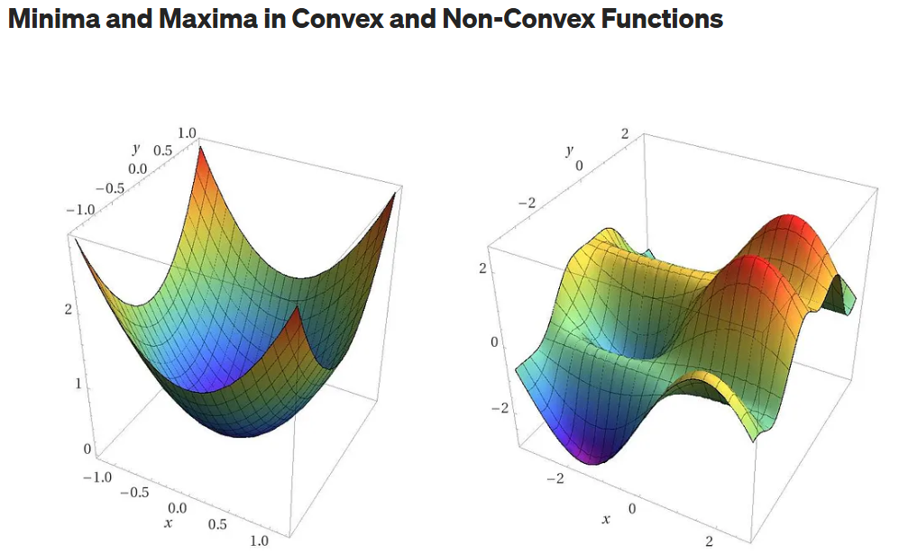

**Why Non-Convex Functions Make Optimization Challenging in Deep Learning:**

1. The optimizer can get stuck in local minima instead of reaching the global minimum.
   1. In a non-convex landscape, there are many **local minima**—points where the loss is lower than all surrounding points, but not the absolute lowest point (the **global minimum**). The optimizer (like SGD) follows the gradient downhill and can get **trapped** in a local minimum, resulting in a model that is trained but performs poorly.
2. Points where the gradient is zero but not a minimum can slow or stop training.
   1. Deep networks contain many saddle points (points where the gradient is zero, but it's not a minimum—it's a minimum in one direction and a maximum in another) and vast plateaus (flat regions).
   2. When the optimizer lands on a saddle point or a plateau, the gradient approaches zero ≈0).
   3. According to the update rule, a near-zero gradient means the weights barely change, effectively slowing or stalling the training process.
3. Deep networks have millions of parameters, leading to highly irregular and non-convex loss landscapes.
4. The final solution can vary depending on how weights are initialized.
5. Finding the optimal parameters is harder and may require advanced optimizers like Adam or momentum-based SGD.

### **Q7. Training and Model Optimization**

Explain the **training process** of a neural network (forward pass, loss calculation, backward pass, parameter update).  
Include techniques used for model optimization (e.g., dropout,SGD, learning rate scheduling, batch normalization).  
 ✎ **Answer:** You can think of it as a feedback system where, after each round of training or 'epoch,' the network reviews its performance on tasks. It calculates the difference between its output and the correct answer, known as the error. Then, it adjusts its internal parameters, or 'weights,' to reduce this error next time. This method is essential for tuning the neural network's accuracy and is a foundational strategy in learning to make better predictions or decisions.

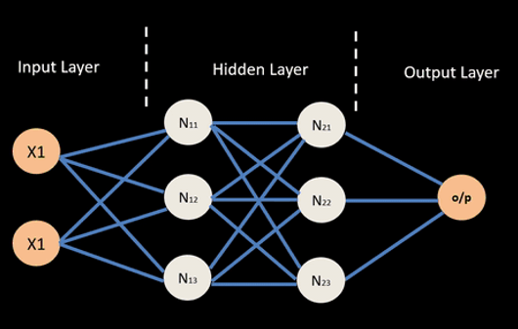

There are 4 main steps involved in a Backpropagation:

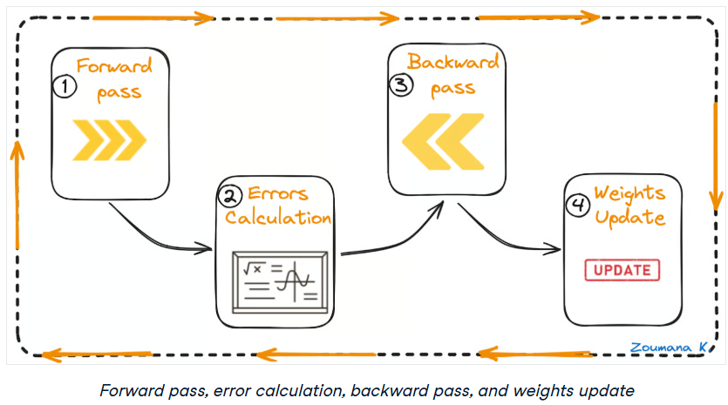

Let’s understand each of these steps from the above animation.

**Forward pass**

This is the first step of the backpropagation process, and it’s illustrated below:

* The data ( inputs X1 and X2) is fed to the input layer
* Then, each input is multiplied by its corresponding weight, and the results are passed to the neurons N1X and N2X of the hidden layers.
* Those neurons apply an activation function to the weighted inputs they receive, and the result passes to the next layer.

**Errors calculation**

* The process continues until the output layer generates the final output (o/p).
* The output of the network is then compared to the ground truth (desired output), and the difference is calculated, resulting in an error value.

**Backward pass**

This is an actual backpropagation step, and cannot be performed without the above forward and error calculation steps.

Here is how it works:

* The error value obtained previously is used to calculate the gradient of the loss function.
* The gradient of the error is propagated back through the network, starting from the output layer to the hidden layers.
* As the error gradient propagates back, the weights (represented by the lines connecting the nodes) are updated according to their contribution to the error. This involves taking the derivative of the error with respect to each weight, which indicates how much a change in the weight would change the error.
* The learning rate determines the size of the weight updates. A smaller learning rate means than the weights are updated by a smaller amount, and vice-versa.

**Weights update**

* The weights are updated in the opposite direction of the gradient, leading to the name “gradient descent.” It aims to reduce the error in the next forward pass.
* This process of forward pass, error calculation, backward pass, and weights update continues for multiple epochs until the network performance reaches a satisfactory level or stops improving significantly.

1. **Dropout**

* Prevents overfitting by randomly deactivating neurons during training.
* At each training step, a fraction (e.g., 0.5) of neurons are "dropped out" — their output is set to zero.
* Forces the network to learn redundant representations, improving generalization.
* Dropout is turned off, and outputs are scaled to match training behavior.

2. **Stochastic Gradient Descent (SGD)**

* **Purpose**: Optimizes model weights by minimizing the loss function.
* **How it works**: Updates weights using gradients computed from small batches of data.
* • Variants:
  + **Momentum:** Accelerates SGD by smoothing updates.
  + **Nesterov Accelerated Gradient:** Improves momentum by looking ahead.
* **Pros:** Efficient for large datasets, simple to implement.
* **Cons:** Sensitive to learning rate and may get stuck in local minima.

**Batch Normalization**

* Stabilizes and accelerates training by normalizing layer inputs.
* Normalizes inputs to have zero mean and unit variance, then scales and shifts them using learnable parameters.

### **Q8. Challenges and Requirements**

List the **main challenges** in deep learning (e.g., data requirements, interpretability, model complexity, computational cost).

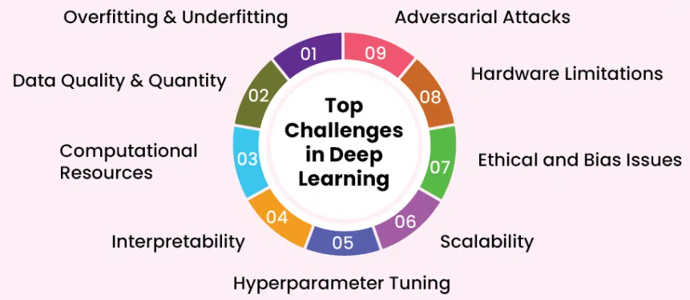

What are the essential **requirements** for building effective deep learning models?  
 ✎ **Answer:**

* Models perform best when trained on large, diverse, and accurately labeled datasets.
* GPUs or TPUs are needed to handle complex computations and speed up training.
* Choosing suitable architectures (e.g., CNNs for images, RNNs for sequences) based on the problem type.
* Optimizing learning rate, batch size, number of layers, and other parameters for better performance.
* Use of dropout, batch normalization, and optimizers like Adam or SGD to prevent overfitting and stabilize training.
* The system should handle large datasets and scale across multiple devices or servers.
* Ensuring fairness and transparency to avoid biased predictions.
* Protecting models from adversarial attacks and ensuring consistent performance in real-world scenarios.
* Regular testing on validation and unseen data to maintain accuracy and generalization.

## **Section B: Deep Learning Frameworks & Implementation**

### **Q9. Deep Learning Frameworks**

List at least **three deep learning frameworks** (e.g., TensorFlow, PyTorch, Keras).  
 Describe their main features and why they are used.  
 ✎ **Answer:** Here are three of the most widely used deep learning frameworks, each with its own strengths and ideal use cases:

**1. TensorFlow:** Developed byGoogle

* **Main Features**:
  + Offers both high-level and low-level APIs for building models.
  + Supports deployment across platforms: mobile, web, and cloud.
  + Includes TensorBoard for visualization and debugging.
  + Strong support for production environments and scalability.

**2. PyTorch:** Developed by Facebook (Meta)

* **Main Features**:
  + Dynamic computation graph (eager execution) for intuitive coding and debugging.
  + Strong integration with Python and NumPy.
  + Excellent support for GPU acceleration.
  + Widely used in academic research and prototyping.

**3. Keras:** Initially independent, now part of TensorFlow

* **Main Features**:
  + High-level API that simplifies model building and training.
  + Modular and user-friendly interface.
  + Runs on top of TensorFlow, Theano, or CNTK (though TensorFlow is now the default backend).

### **Q10. Building Neural Networks with Keras and TensorFlow (Book Reference: Chapter 3)**

Explain how neural networks can be built using **Keras** and **TensorFlow**.  
 Include key steps such as:

* Defining layers

model = Sequential([

Dense(64, activation='relu', input_shape=(5,)),

Dense(32, activation='relu'),

Dense(1, activation='sigmoid') ])

* Compiling the model

model.compile(optimizer='adam', loss='binary_crossentropy',

metrics=['accuracy'])

* Training and evaluating performance

model.fit(X_train, y_train, epochs=50, batch_size=32, validation_split=0.2)

loss, accuracy = model.evaluate(X_test, y_test)

print(f"Test Accuracy: {accuracy*100:.2f}%")

### **Q11. Data Preprocessing, Feature Engineering, and Feature Learning (Book Reference: Chapter 4)**

Define the following in the context of neural networks:

* **Data preprocessing**
  + Data preprocessing refers to the transformation of raw data into a clean and usable format before feeding it into a neural network.
  + **Key Steps**:
    - **Cleaning**: Removing noise, handling missing values, and correcting inconsistencies.
    - **Normalization/Standardization**: Scaling features to a consistent range (e.g., 0–1 or mean=0, std=1) to improve convergence during training.
    - **Encoding**: Converting categorical variables into numerical formats (e.g., one-hot encoding).
    - **Splitting**: Dividing data into training, validation, and test sets.
  + Neural networks are sensitive to input data quality. Poor preprocessing can lead to slow training, overfitting, or inaccurate predictions.
* **Feature engineering**
  + Feature engineering involves creating new input features or modifying existing ones to better represent the underlying patterns in the data.
  + **Techniques:**
    - **Transformation:** Applying mathematical functions (e.g., log, square root) to existing features.
    - **Aggregation:** Combining multiple features (e.g., average, sum) to create new ones.
    - **Interaction Terms**: Creating features that capture relationships between variables.
    - **Domain Knowledge:** Using insights from the problem domain to craft meaningful features.
  + Well-engineered features can make patterns more detectable by the neural network, improving accuracy and reducing training time.
* **Feature learning** Explain their importance in preparing data for deep learning models.  
   ✎ **Answer:** 
  + - **Automates Representation Discovery**: Deep neural networks, especially convolutional and recurrent architectures, can learn hierarchical features directly from raw data (e.g., pixels, audio signals, text), reducing the need for manual intervention.
    - **Improves Model Accuracy**: Learned features are often more abstract and informative than handcrafted ones, enabling the model to generalize better to unseen data.
    - **Reduces Human Bias**: Since features are learned from data rather than designed by humans, the model may uncover patterns that humans might overlook or misinterpret.
    - **Enables End-to-End Learning**: Feature learning supports end-to-end training pipelines where raw data is fed directly into the model, simplifying workflows and improving scalability.

## **Section C: Image Classification Concepts**

### **Q12. What is Image Classification?**

Define image classification.  
 Give two examples where image classification is applied in real-world scenarios.  
 ✎ **Answer:** Image classification is a computer vision task in which a model analyzes an image and assigns it to one or more predefined categories or labels. It involves training a deep learning model (usually a Convolutional Neural Network, CNN) to recognize visual patterns and features within images.

**Real-World Examples:**

1. Classifying X-rays or MRI scans to detect diseases such as pneumonia, tumors, or fractures.
2. Identifying objects like pedestrians, traffic signs, and other vehicles to assist in safe driving decisions.

### **Q13. Introduction to ImageNet**

**What is the ImageNet dataset, and why is it important for deep learning research?  
 Mention the ImageNet Challenge and how it transformed computer vision.**  
 ✎ **Answer:** ImageNet is a large-scale, publicly available image dataset created to advance research in computer vision and pattern recognition. It contains **over 14 million images** that have been **manually annotated** to indicate the objects present in them, covering more than **20,000 object categories** such as animals, vehicles, tools, and everyday items. These images were collected from the internet and verified by human annotators.

ImageNet played a **transformative role in the development of deep learning**. Its massive scale allowed deep neural networks, which require large amounts of data, to be trained effectively for the first time. The dataset became a **benchmark standard** for testing new models in image classification, object detection, and segmentation.

ImageNet Large Scale Visual Recognition Challenge (ILSVRC) was introduced in **2010**, is an annual competition where researchers submit algorithms to classify and detect objects in a subset of ImageNet — specifically **1.2 million images across 1,000 categories**.

The challenge became a major driving force for innovation in computer vision. The **turning point** came in **2012** when **AlexNet**, was developed and achieved a **top-5 error rate of 15.3%**, far surpassing the previous best of around 26%. This was the first time a **deep convolutional neural network (CNN)** was used successfully on such a large dataset, proving that deep learning could outperform traditional machine learning methods.

### **Q14. Classification using a Single Linear Threshold (Perceptron)**

Explain how a **single-layer perceptron** works for binary classification.  
 Include the mathematical formula and how it decides the output.  
 ✎ **Answer:** A **single-layer perceptron** is the simplest form of an artificial neural network used for **binary classification** — that is, separating data into two classes (e.g., 0 or 1, yes or no, +1 or −1).

The perceptron takes several **input features**, multiplies them by corresponding **weights**, adds a **bias**, and then applies an **activation function** to decide the output class.

### **Q15. How Interpretable Are Deep Learning Features?**

**Why are deep learning models considered “black boxes”?  
 Describe one method (e.g., Grad-CAM, feature visualization) used to interpret model features.**  
 ✎ **Answer:** Deep learning models are often called **“black boxes”** because, although they can make highly accurate predictions, it is difficult to understand how or why they arrive at those decisions.

Neural networks consist of many layers and thousands (or even millions) of parameters that interact in complex ways. Unlike traditional models such as decision trees, where decision paths are clear, deep networks **learn abstract representations** inside hidden layers that are not easily interpretable by humans.

For example, in an image classification model, we can see the input (the image) and the output (the predicted class), but the internal reasoning — which features or regions the model focused on — is hidden inside the network’s weight structure.

**Grad-CAM** is a popular technique used to visualize **which parts of an image** influenced the model’s prediction. It works mainly for **Convolutional Neural Networks (CNNs)**.

**How it works:**

1. It calculates the **gradients** of the target class (for example, “cat”) with respect to the final convolutional layer of the network.
2. These gradients highlight **which neurons** were most important for predicting that class.
3. Grad-CAM then overlays a **heatmap** on the original image to show **regions the model focused on** — bright areas indicate high importance.

**Example:**  
If a CNN predicts “dog,” the Grad-CAM heatmap might highlight the dog’s face and body, showing that these parts strongly influenced the model’s decision.

### **Q16. Manipulating Deep Nets**

**Explain what adversarial examples are and how they can trick deep learning models.  
 Suggest one way to make neural networks more robust against such attacks.**  
 ✎ **Answer:** Adversarial examples are intentionally modified inputs (like images, audio, or text) that are designed to fool deep learning models into making incorrect predictions.

These modifications are usually tiny and almost invisible to humans, but they cause the model to misclassify the input with high confidence. A deep learning model learns patterns from data by adjusting weights to minimize loss. However, these models are highly sensitive to specific directions in input space. Attackers exploit this by adding small perturbations to the input that push it across the model’s decision boundary.

They trick Deep Learning models because:

* Deep networks learn **complex but fragile patterns** that don’t always align with human perception.
* These small perturbations exploit **non-linearities** in high-dimensional feature spaces.
* Models often **overfit** to training data distribution and fail on slightly altered inputs.

One common way to make neural networks more robust is Adversarial Training. In this method, we train the model not only on clean data but also on slightly modified (adversarial) examples. This helps the model learn to recognize and resist such small, tricky changes.

### **Q17. Transfer Learning**

What is **transfer learning**, and how does it help when data is limited?  
 Mention two pre-trained models commonly used for transfer learning.  
 ✎ **Answer:** Transfer learning is a machine learning technique where a model developed for a large-scale task is reused as a starting point for a second, related task. Essentially, you transfer the knowledge (patterns and features learned) from a pre-trained model to a new problem, instead of training a new model from scratch.

**How Transfer Learning Helps with Limited Data**

Deep learning models typically require massive amounts of labeled data and significant computational power to train effectively from scratch. Transfer learning provides a critical solution when your specific dataset for the target task is small or limited because of the following reasons:

* **Feature Reusability:** The layers of a pre-trained model have already learned **general and generic features** from the enormous source dataset. For instance, a model pre-trained on millions of natural images has learned fundamental features like edges, textures, and basic shapes. These features are highly relevant to almost any new image task.
* **Mitigates Overfitting:** With a small dataset, training a deep model from scratch would often lead to **overfitting** (the model memorizing the training data instead of generalizing). Transfer learning prevents this by starting with a set of well-generalized weights. You typically only retrain a small, task-specific portion of the model (the output layer), which drastically reduces the number of parameters that need to be learned from your limited data.
* **Faster Convergence:** Since the model already has a great starting point, it takes much less time and fewer iterations (epochs) to train on the new task compared to training from a random initialization. This saves both time and computational resources.

These models are widely used because they were trained on massive, diverse datasets, making their learned features broadly applicable.

1. **ResNet (Residual Network):**
   * Computer Vision (Image Classification).
   * Trained extensively on the **ImageNet** dataset (millions of images across 1,000 object categories).
   * Its architecture, known for using "skip connections" to allow for deep networks, is excellent for feature extraction. Practitioners load the pre-trained weights and adapt the model for new image tasks like medical image classification or recognizing specific objects in an industrial setting.
2. **BERT (Bidirectional Encoder Representations from Transformers):**
   * Natural Language Processing (NLP).
   * Trained on enormous amounts of text data (e.g., Wikipedia and BookCorpus) to understand language, context, and grammar.
   * BERT is the foundation for numerous NLP applications. With a limited, custom text dataset, you can **fine-tune** the pre-trained BERT model to perform specific tasks, such as sentiment analysis, question answering, or text classification, by adjusting its weights slightly for the target domain.

## **Section D: Applications of Deep Learning**

### **Q18. Applications in Data Science**

Explain at least **three applications of deep learning in data science** (e.g., Speech Recognition, Image Classification, NLP, Predictive Analytics, Computer vision, Healthcare).  
 ✎ **Answer:** Following are some Application of Data Science in Real-World:

**1. Speech Recognition:**

Deep learning models such as **Recurrent Neural Networks (RNNs)** and **Transformer-based architectures** (like Whisper or wav2vec) can understand and convert human speech into text.

* **Use Case:** Voice assistants like **Google Assistant**, **Siri**, and **Alexa** use deep learning to recognize spoken commands.
* **Impact:** It enables hands-free control, transcription services, and improved accessibility for users.

**2. Natural Language Processing (NLP):**

Deep learning helps computers understand and generate human language using models like **BERT**, **GPT**, and **LSTMs**.

* **Use Case:** Chatbots, language translators, and sentiment analysis systems that detect emotions in customer feedback.
* **Impact:** Improves human-computer communication, automates customer service, and enhances text-based analytics.

**3. Computer Vision & Image Classification:**

Deep learning models such as **Convolutional Neural Networks (CNNs)** are used to analyze and interpret visual data from images or videos.

* **Use Case:** Detecting diseases in medical scans, recognizing faces in security systems, or identifying objects in self-driving cars.
* **Impact:** Helps in medical diagnosis, surveillance, automation, and navigation.

### **Q19. Case Study 1: Data Scientist Employee Attrition**

***Read the scenario and answer:***

A company wants to predict whether a **data scientist** will leave the organization.  
 They collect data such as age, salary, experience, satisfaction, and commute distance.

1. What kind of problem is this (classification or regression)?
   1. This is a **classification problem** because the goal is to predict whether a data scientist will **leave (Yes/No)** or **stay** in the organization.
2. Suggest an appropriate deep learning model architecture.
   1. An appropriate model would be a Simple MLP (Multi Level Perceptron)
      1. **Input layer:** receives numerical features like age, salary, experience, satisfaction, and commute distance.
      2. **Hidden layers:** 2–3 dense (fully connected) layers with activation functions like ReLU to learn complex relationships between factors.
      3. **Output layer:** 1 neuron with a sigmoid activation function
3. What type of loss function should be used?
   1. Use **Binary Cross-Entropy Loss**, which measures the difference between the predicted probability and the actual class. It is mostly used for binary classification tasks.
4. How can the results help HR management?
   1. HR can understand which factors (e.g., low satisfaction or long commute) increase the chance of employees leaving.
   2. Early detection helps HR take preventive actions such as improving work conditions or offering incentives.
   3. Insights can guide hiring, compensation, and employee engagement strategies.

## **Section E: Practical Project**

### **Q20. Project – Handwritten Digit Classification (MNIST Dataset)**

**Objective:** Build an **Artificial Neural Network (ANN)** using **Keras** and **TensorFlow** to classify handwritten digits (0–9) from the **MNIST dataset**.

**Requirements:**

* Load and preprocess the MNIST dataset.
* Design a suitable **ANN architecture**.
* Train and evaluate the model for accuracy.
* Visualize the results (confusion matrix, accuracy/loss curves).

**Deliverables:**

* Model summary and architecture diagram
* Accuracy and loss graphs
* Sample predictions (images + predicted labels)
* Short explanation of results

✎ **Answer / Attach Code Link:**

## **Section F: Reflection (Bonus)**

### **Q23. Your Thoughts on Deep Learning**

**In your opinion:**

* What makes deep learning powerful?
* What ethical or practical issues should be considered in its real-world use?

### ***✅ End of Assignment***